1. Write a shell script to print arguments passed to the script in reverse order.
Input: sh script.sh 2 5 3
Output:
3
5
2
Ans:
-> vi 1.reverse-order.sh

#!/bin/bash

for ((i=$#; i>0; i--))
do
echo "${!i}"
done

Output: [ec2-user@ip-172-31-39-119 ~]$ bash 1.reverse-order.sh 2 3 5
5
3
2
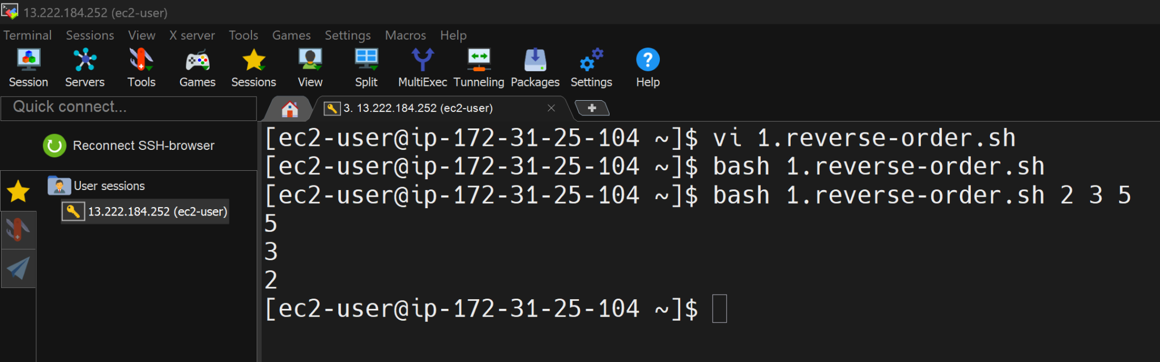
Explanation for me: Why "${!i}" ?
This is called indirect parameter expansion in Bash.

Normal case:
echo "$1"

This prints the first argument.
But here i is a variable:
i=3

If you do:
echo "$i"

It prints 3

But you want:
echo "$3"

So how do you dynamically access $1, $2, $3 using a variable?
That’s where ${!i} comes in.

2. Write a script that monitors system performance and sends a mail notification with warning messages about resource usage like ram, disk usage.
Ans:

First we set up an email client on the server to send email from the server.

-> sudo yum install s-nail cyrus-sasl-plain -y
Note: First you need to get the app password from gmail for smtp settings. Go to manage your google account >> search for "App password" from the search bar as it won't be visible in the dashboard. Then you can set the app password and use it.

→ vi ~/.mailrc

# Set MTA to use Gmail's SMTP server with STARTTLS
set mta=smtp://smtp.gmail.com:587
# Authentication settings
set smtp-auth=login
set smtp-auth-user=nagarajkamath602@gmail.com
#Update gmail app password in smtp-auth-password
set smtp-auth-password=wcelrtsjlqbenfzs
# Email settings
set from="nagarajkamath602@gmail.com"
# Enable TLS
set ssl-verify=ignore
set smtp-use-starttls

→ :wq

Once smtp is set up, we will write a script to monitor resource usage.

-> vi 2.performance_report.sh

#!/bin/bash

DISK_THRESHOLD=80
#For testing, I set RAM threshold as 25
RAM_THRESHOLD=25
EMAIL="nagarajkamath602@gmail.com"

# Get usage values
disk_usage=$(df -h / | awk 'NR==2 {print $5}' | sed 's/%//')
ram_usage=$(free | awk 'NR==2 {print int($3*100/$2)}')
load_avg=$(uptime | awk -F'load average:' '{print $2}')

alert_flag=0

# Check Disk
if [ "$disk_usage" -ge "$DISK_THRESHOLD" ]; then
disk_status="HIGH"
alert_flag=1
else
disk_status="OK"
fi

# Check RAM
if [ "$ram_usage" -ge "$RAM_THRESHOLD" ]; then
ram_status="HIGH"
alert_flag=1
else
ram_status="OK"
fi

# Send email only if any resource is HIGH
if [ "$alert_flag" -eq 1 ]; then
echo -e "
=========================================
SYSTEM RESOURCE ALERT
=========================================

Hostname : $(hostname)
IP : $(hostname -I | awk '{print $1}')
Date : $(date)

-----------------------------------------
Resource Usage
-----------------------------------------

Disk Usage : ${disk_usage}% [$disk_status]
RAM Usage : ${ram_usage}% [$ram_status]

Load Average (1m, 5m, 15m):
$load_avg

-----------------------------------------
Action Required: Please investigate.
=========================================
" | mail -s "ALERT: Resource Usage on $(hostname)" "$EMAIL"
fi

:wq

-> crontab -e

*/5 * * * * bash /home/ec2-user/2.performance_report.sh - -> run it every 5 minutes

For testing purpose: To generate high disk usage run:
fallocate -l 7G testfile.img

To kill it:
rm -f testfile.img



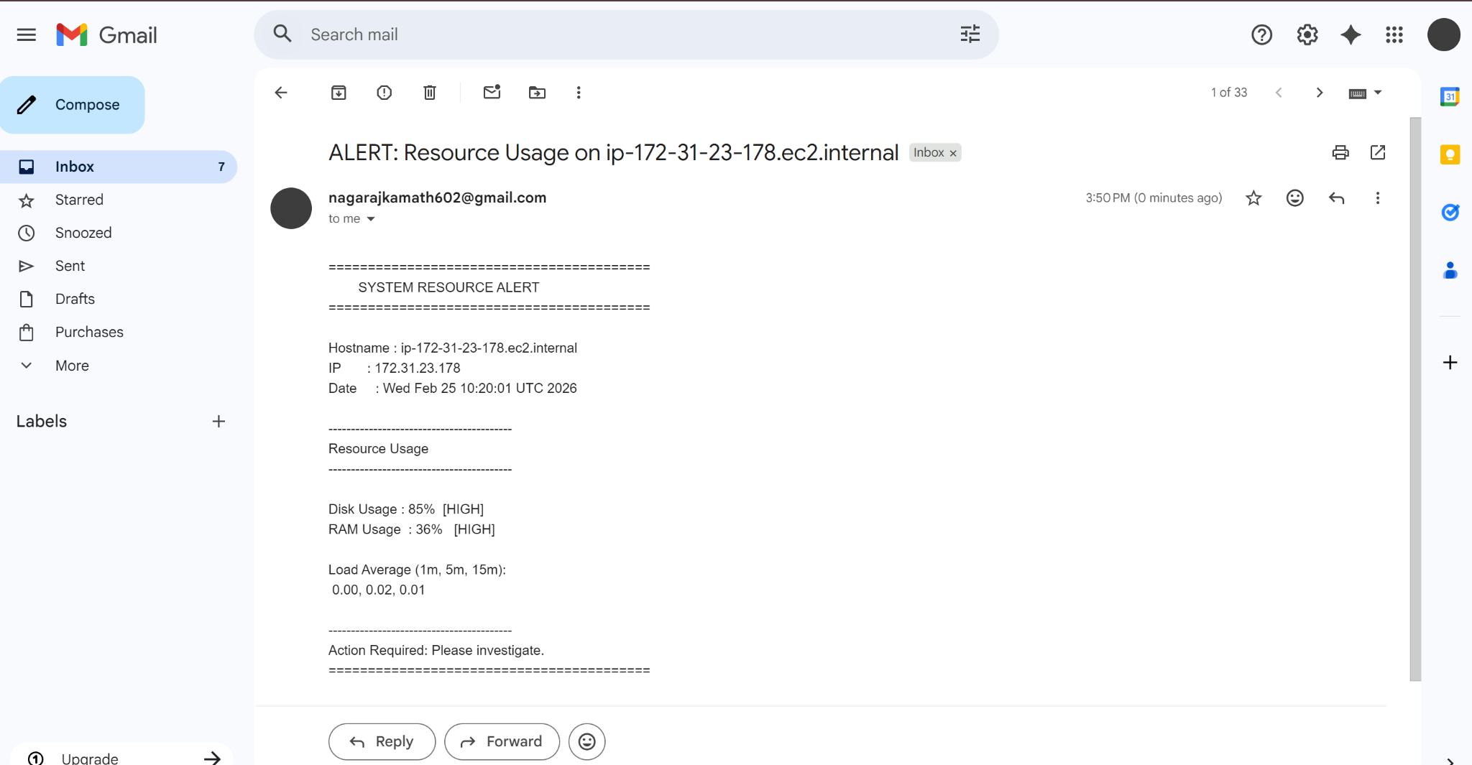

3. Write a script to find the files in a directory that were last modified more than 4 weeks ago [For Practise use Mins/Days] and delete them, starting with the ones that consume the most space.
Ans:

-> vi cleanup_old_files.sh

#!/bin/bash
DIR="/home/ec2-user/testdir"

find "$DIR" -type f -mtime +28 -size +10M -exec echo "Deleting: {}" \; -delete

Output: Created file with 10mb storage 40 days ago. (Used wget to get tomcat file and copied it to different files and used touch -d "40 days ago" <file-name> to change the timestamp)

→ Bash cleanup_old_files.sh
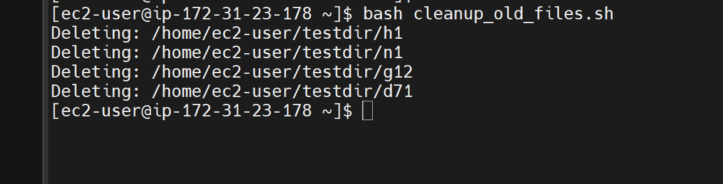

4. Explain the difference between running a script with ' ./script' and running it with ' nohup ./script &'
Ans:
- ./script →runs the script in the foreground, tied to the terminal.
- nohup ./script & →runs the script in the background, independent of the terminal.

Explanation for me:
1. Running a script with ./script

Let's say you have a script called backup_data.sh that takes a few minutes to run. If you run it with ./backup_data.sh, the script will occupy the terminal until it finishes:

$ ./backup_data.sh
Backing up data... (takes 5 minutes)

You won't be able to use the terminal until the script finishes. If you close the terminal or press Ctrl+C, the script will be interrupted.

2. Running a script with nohup ./script &

If you run the same script with nohup ./backup_data.sh &, the script will run in the background, freeing up the terminal:

$ nohup ./backup_data.sh &
[1] 12345
$

The script will continue running even if you close the terminal or press Ctrl+C. The output will be logged to a file named nohup.out:

$ cat nohup.out
Backing up data... (takes 5 minutes)

You can check the script's progress by tailing the log file:

$ tail -f nohup.out

These examples illustrate the difference between running a script in the foreground (with ./script) and running it in the background (with nohup ./script &).

5. Read an integer ' n ' and generate the following pattern:
1
1 2
1 2 3
1 2 3 4 up to ' n ' rows.
Ans:
-> vi pattern.sh

#!/bin/bash

echo "Enter the number"
read n

for((i=1; i<=n; i++))

do
for((j=1; j<=i; j++))
do
echo -n " $j"
done
echo ""
done

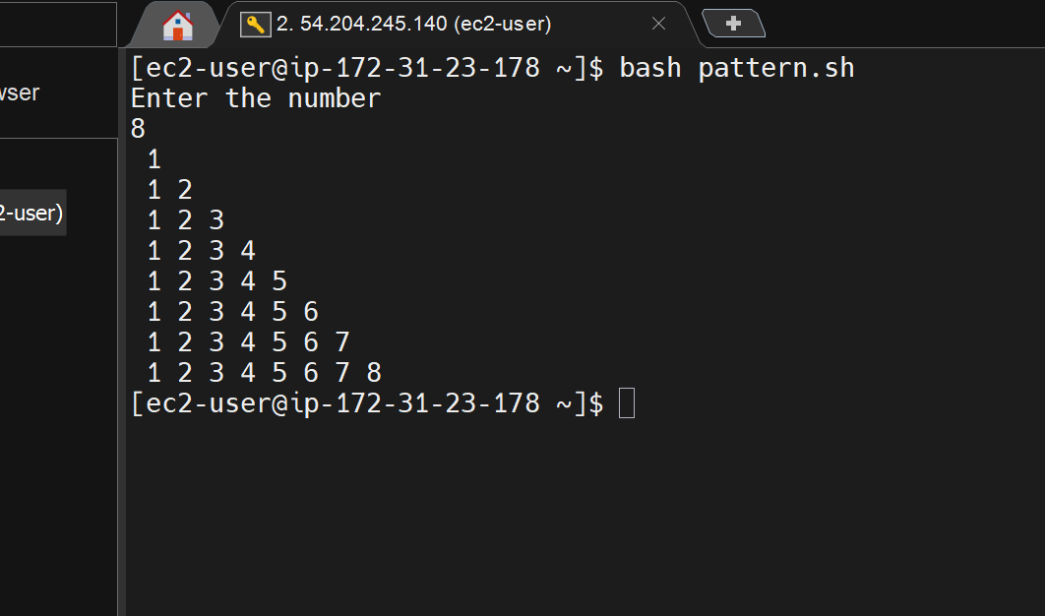

6. Write a script to display the contents of the file in reverse order without using tac command
Ans:
-> vi reverse_file.sh

#!/bin/bash

while read line
do
output="$line"$'\n'"$output"
done < "$1"

echo -e "$output"

Output:
-> vi example.txt
100
200
300
400
500
600
700
800
900
:wq

-> bash reverse_file.sh example.txt
900
800
700
600
500
400
300
200
100

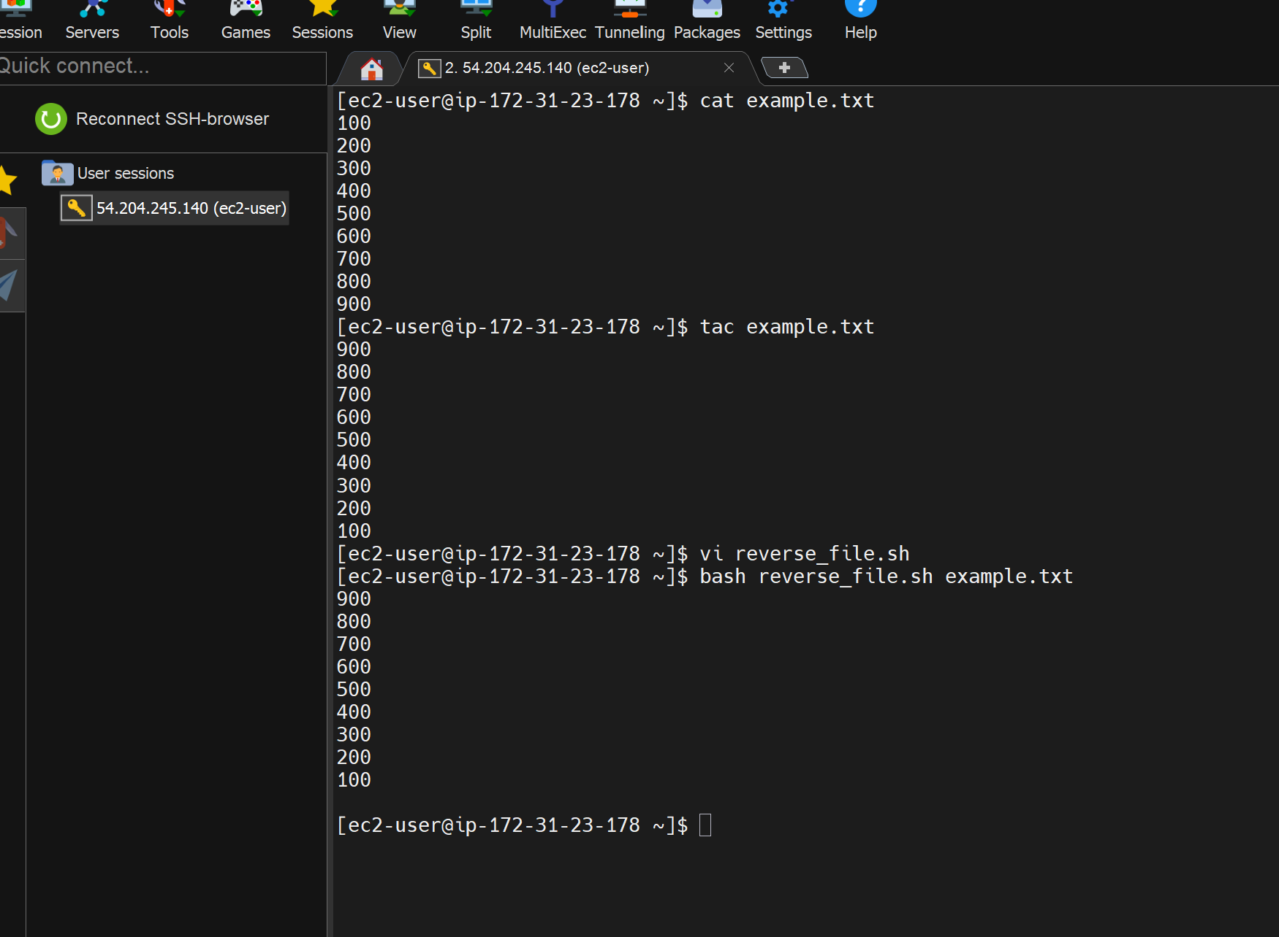

7. Write a script to reverse a string using while loop
Input: hello
Output: olleh
Ans:
-> vi reverse_string.sh
#!/bin/bash

echo "Enter a string:"
read string

i=$(echo -n "$string" | wc -c)

while [ $i -gt 0 ]
do
char=$(echo -n "$string" | cut -c $i)
echo -n "$char"
((i--))
done

echo

Output: 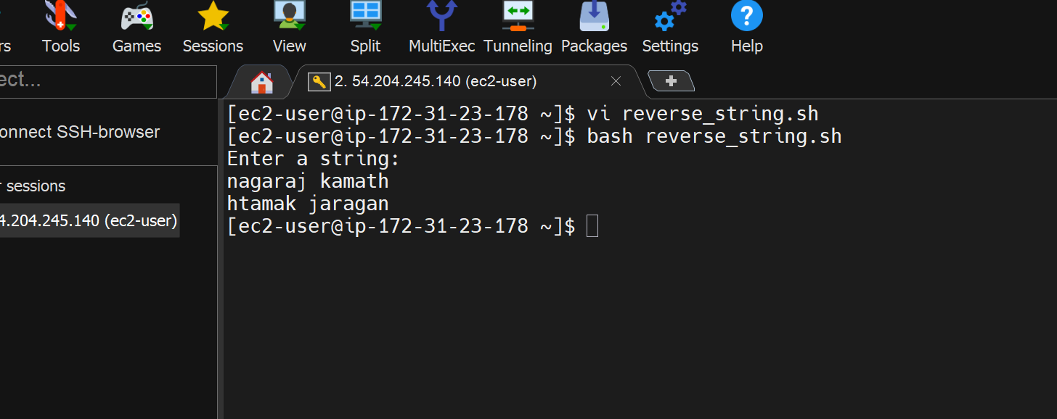

8. Read an integer 'n' and generate the following pattern:
1
2 3
4 5 6
7 8 9 10
up to n rows.

Ans:

-> vi pattern_add.sh

#!/bin/bash

read -p "Enter the value of n: " n

num=1
for ((i = 1; i <= n; i++)); do
for ((j = 1; j <= i; j++)); do
echo -n "$num "
num=$((num + 1))
done
echo
done

Output:
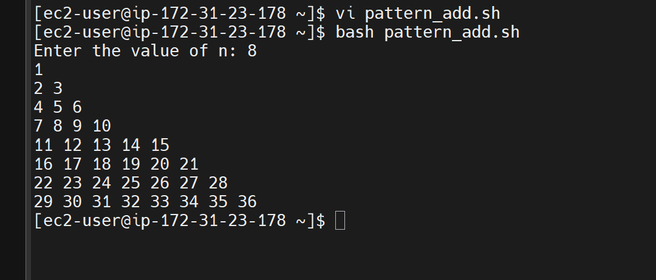

9. Write a script that rename a file or directory by replacing its letters with lowercase from uppercase letters. Example: TEst.txt → test.txt
Ans:
-> vi rename.sh

#!/bin/bash

echo "Enter the file or directory name"
read name

echo -e "\n\n$name is renamed to:"

new_name=${name,,}

# Rename the file or directory
mv "$name" "$new_name"
echo -e " $new_name\n"

Explanation: The ${name,,} syntax converts the name to lowercase, using the bash parameter expansion feature.
Output:
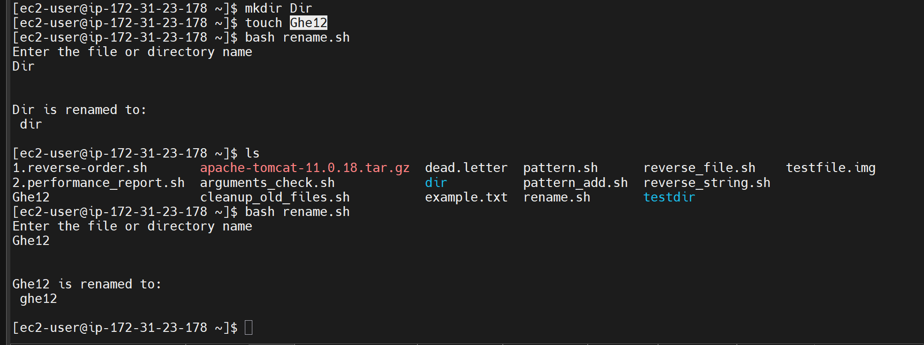

10. Write a script that takes multiple inputs from the user as arguments and only prints the arguments if they are integers
Input: sh script.sh abc 2 t5 4 efg ghi 34 67 1 2
Output:
The integer arguments are:
2
4
34
67
1
2

Ans:
-> vi arguments_check.sh

#!/bin/bash

echo "The integer arguments are:"

for arg in "$@"
do
if [[ "$arg" =~ ^[0-9]+$ ]]
then
echo "$arg"
fi
done

Explanation: Using =~ means
[[ "$a" =~ ^[0-9]+$ ]]
Matches full regular expression.
^ Start of string
[0-9]+ One or more digits
$ End of string

Output:
